## System Layout

The system layout is a visible representation of the complete topology. Here you can find all the devices and interfaces with their respective connections (see Figure 2‑38).

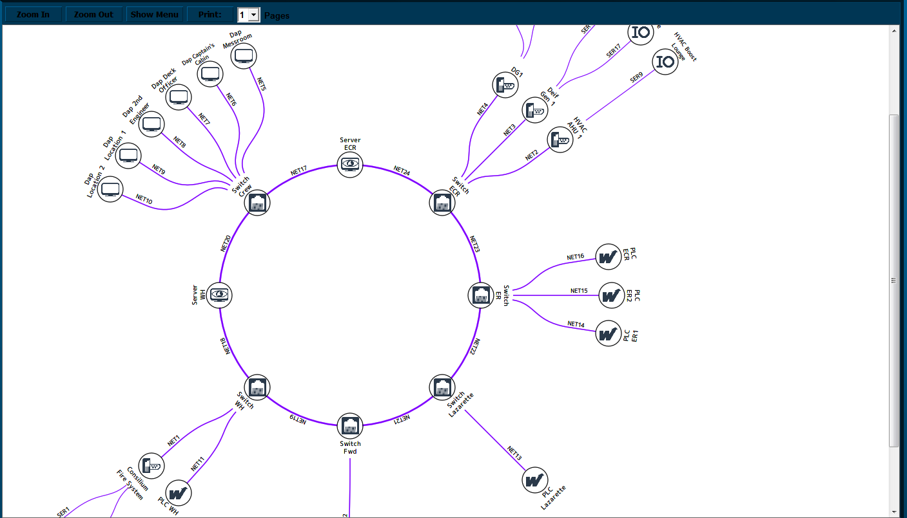

Figure 2‑38: System Layout

If set-up alright here you will find a perfect circle with all the separate devices attached. Also the names of the devices and interfaces will be available. You can zoom in and out and print the page.

The lines are at first purple, which means that the connection haven’t been seen yet. Once the connection is established, the lines should turn green. It is, of course, important that all the lines are green for the system to work properly. If a connection gets lost, the line, and all the adjacent lines that are influenced, will turn red, meaning that the connection is lost. An alarm will also appear.

This is perfect for quick troubleshooting of the network.